LA COUPE LONGUEUIL
An event people will talk about for generations.
By Tibum the goblin

TEAM BUILD & SKILL SELECTION
The Coupe Longueuil will be using the Amorical Cup ruleset, with the major change being this is an individuals tournament rather than a team tournament. We have cut the Amorical ruleset down for your information below.
You may want to view the rules on the Amorical Website as well at https://amoricalcup.com/ruleset/?fbclid=IwAR2PwvkNtosL-HKr7ScNCkZx5vXcneYhFerNRBCZYeLC_GEjaOGI8tSGihY
Step 1:
Select your Race. Each race has a cost as per the attached table. Also please note the associated budget of gold pieces each race receives from which the coach can build their roster. Ignore the Squad points. They are for the team aspect of the Amorical Cup.
Step 2:
Each coach may provide their players a given number of additional skills or may recruit a Star Player (or a Mega Star). The second table attached provides the information coaches will need for the construction of their roster in terms of additional skills and/or Star Players.
As an example of the above, A Dwarf team (Tier A) receives 4 Skill Points. Thus, they may give four players one Primary Skill each and they are not allowed any Secondary Skills. However, should the Dwarf coach so decide, they may spend one Skill Point and stack two Primary Skills on a key player. Should they decide to do so, however, this means the total number of additional skills on their team drops from four to three, two of which are now stacked on one player. Finally, as a Tier A team, the Dwarf coach may not choose to recruit a star player.
The lists of Star Players and Mega Stars can be found in the Blood Bowl Matched Play Guide as well as on Page 13 of the Blood Bowl FAQ that you can find here: https://www.warhammer-community.com/wp-content/uploads/2017/11/Ep9CKKCUD7ts8c6D.pdf?fbclid=IwAR14RjJjn4hzw8Epb5Qfdli5cKoAGhiY_hzgPFpcnfJVjyWoJqsArUfKdwg
Step 3:
As part of their build, coaches may purchase Inducements. The cost of the inducements can be found in the Blood Bowl core rule book or the Death Zone supplement. However, please note that selecting some inducements will have a cost that must be deducted from the budget of Skill Points allocated to each team depending on their tier. Hence, an Orc team that elects to purchase a Biased Referee will see their Skill Point total fall from 4 to 3 for the purposes of adding skills to their players. Table is attached.
Please note that some Inducements are not/not permitted at the Amorical Cup.
How does someone Win this?
Points will be awarded each game as follows:
2 Points for a win, 1 Point for a draw and 0 for a loss.
Tiebreakers:
Head-to-Head Record › Opponent score › Net TDs › Net CAS › Coin Toss
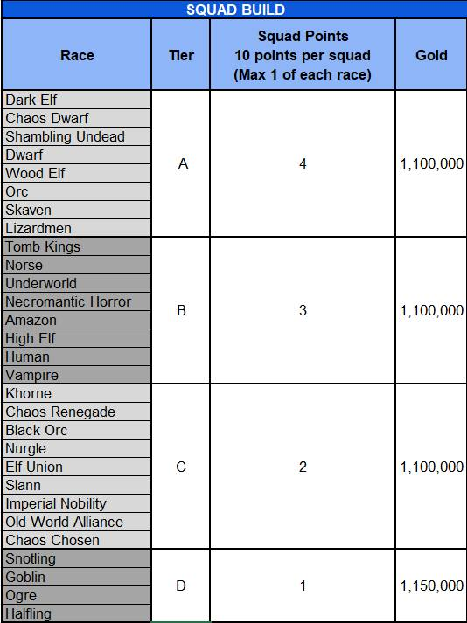

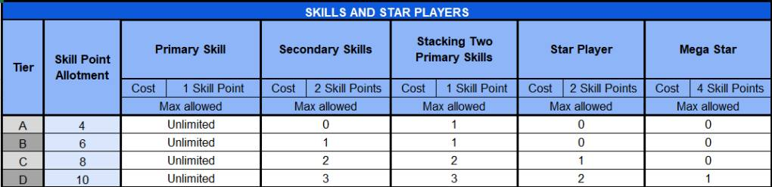

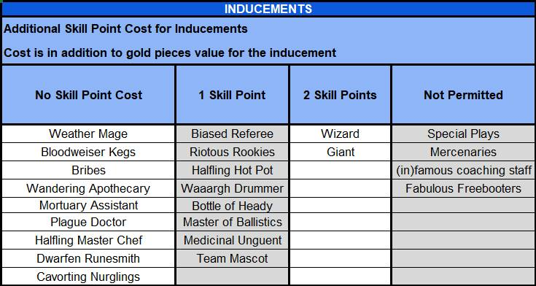

KICK OFF TABLE (D16)
1. Make-a-Squish Foundation
The Make-a-Squish Foundation raises funds to make the dreams of sick children come true. One of these kids named “Tiny Tim” made a wish to meet Tibum and score a touchdown in a Blood Bowl game. However, the players on the field seem less enthusiastic about having to interrupt the match. The opposing team doesn’t seem to have gotten the memo!

When this event is rolled, the receiving coach places Tiny Tim in possession of the ball on the central square of his half of the pitch. Tiny Tim is controlled by the coach of the team that received the ball and is considered part of the team. At the end of the Drive, Tiny Tim leaves the game.
Tiny Tim’s characteristics are as follows:

Tiny Tim
MA ST AG PA AV
4 1 4+ 4 + 4+
Skills and Traits: Animosity (4+, all Team Mates), Right Stuff, Stunty
Special Rules: Feature of the day: When rolling for an animosity roll, Tiny Tim will only agree to give or pass the ball on a roll of 4+

2. Get the Ref!
The coaches need to go beg Tibum for a bribe (DO IT) (YES, DO IT IRL)
Tibum will give them each a Bribe valid for the duration of the match.

3. Jammed on the bridge? Take the metro! (Time-Out)
If the kicking team’s turn marker is on turn 6, 7 or 8 for the half, both coaches move their turn marker back one space. Otherwise, both coaches move their turn marker forward one space.

4. Perfect Defense
D3+3 Open player on the kicking team may be removed and set up again in different locations, following all of the usual set up rules.

5. High kick
One open player on the receiving team may be moved any number of squares, regardless of their MA, and placed in the same square the ball will land in.

6. Tibum is here!?
Tibum’s popularity is out of control and his fans are worthy of groupies from the biggest rock bands! Some players have heard of Tibum’s presence at the event and are even willing to miss part of the match in hopes of meeting him.

Each Coach must roll a d6. The coach with the lowest result must randomly select 1D3 of his players who will be removed from the field and miss a turn.
Selected players will then be able to enter the game through the trapdoor located on their side of the pitch. The coach can choose the squares around the trapdoor and place these players there at the start of the second round. Players are considered to have not yet taken any action this turn.
In the event of a draw on the die roll, both teams will have players affected by the event.

7. Splendid COUPE LONGUEUIL!
Each Coach must roll a d6. The coach with the highest result will have to randomly select one of his players who will be touched by the gods of the COUPE LONGUEUIL.
Indeed, the player’s IMMACULATE hair will make him SO BEAUTIFUL that his opponents will hesitate to attack him. Consider the player as having the Foul Appearance skill (In this case we will say AWESOME appearance!) In the event of a draw on the die roll, both teams will have one player affected by the event.

8. Longueuil by the beach (Changing Weather)
Make a new roll on the Weather table and apply result. If the weather conditions are “Perfect Conditions” as a result of this roll, the ball will scatter, as described on page 25, before landing.

9. Disturbing crowd
One of the club’s fans are particularly enjoying their Blood bowl tournament.
The numerous insults and objects thrown on the field make it very difficult for players to concentrate.

Randomly select which side of the pitch the crowd is disrupting. (Heads or tails) Consider the wide zone from one end of the field to the other as being affected by the Disturbing Presence skill.
(-1 to Passes, Team-mate Throws, Bomb Throws, attempts to Catch or Interfere with a Pass)

10. BLITZ!
D3+3 Open players on the receiving team may immediately activate to perform a Move action. One can perform a Blitz action and one can perform a Throw Team-mate action. If a player Falls over or is Knocked Down, no further players can be activated and the Blitz ends immediately.

11. Counting to 11 is not easy for everyone!
The referee in charge of the match is convinced that too many players are on the pitch and wants to remove the “Extra” players.
Each coach rolls a D6 and on a result of 2+, a randomly selected player returns to the reserve for the drive. The coach can use a Bribe to convince the referee to let the player stay on the field!

12. Watch out for the deer! (Pitch Invasion)
The deer problem in Longueuil has not been resolved yet and unfortunately, some players learn it the hard way.

Each Coach must roll a d6. The coach with the lowest result must randomly select 1D3 of his players who will be stunned.

13. Potholes!
Respectable (HUGE) sized potholes began to form on the ground. The city promises to come and repair them soon.

The 2 Trapdoors are considered as the crowd for the duration of the Drive. A player cannot voluntarily enter them and a player who unintentionally enters these squares is considered to have been pushed into the crowd. It is, however, possible to jump over it as if it were a Prone player, or by using the Leap skill.

14. One beer too many in the old Longueuil! (or 6!?)
Some local phenoms have invited one of the players to the local taverns and, despite protests from his new friends, he manages to make it back to the stadium in time for kick-off! (But not before having a little too much to drink!)

Each Coach must roll a d6. The coach with the lowest result will have to randomly select one of his players who has drunk one beer too many in old Longueuil. The player will receive Loner 4+ until the end of the drive. In the event of a draw, both teams will have one player affected by the event.

15. Bloodbath 50
A local beer company sponsors the tournament and mass supplies their star product: The Big Bloodbath 50, tablet. The enthusiastic crowd appears to get rid of the empty bottles by throwing them onto the field. Some even try to aim for the players with bottles that are sometimes still full!

Each Coach receives a single-use Big Bloodbath 50. He can use it at the end of any coach’s turn (like a wizard). When a coach uses his Big Bloodbath 50, he designates a player on the field and must roll a d6. On a result of 2+, an armor roll is made against the player as if they had been hit by the Stab skill.

16. Who’s a lucky humie!? YOU ARE!
Each Coach must roll a d6. The coach with the highest result chooses to obtain 1 reroll or a bribe for the drive. The opposing coach will be given the other option.

